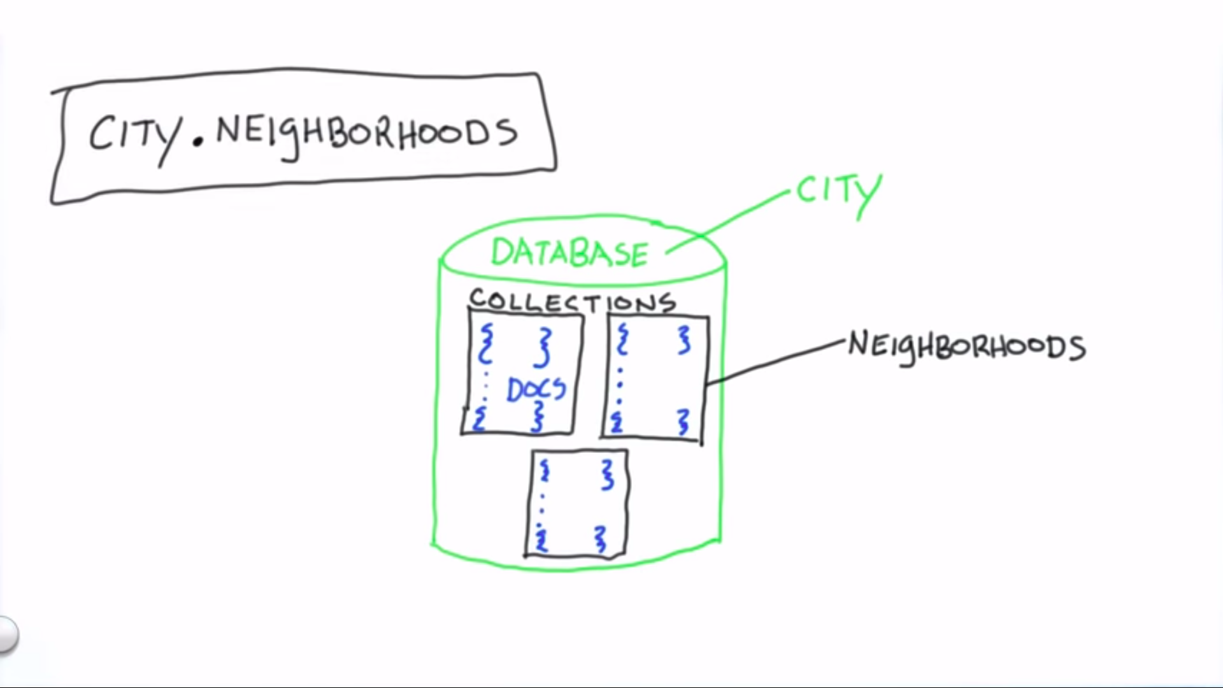

1. An overview of the hierarchy of MongoDB where City represents Database and Neighbourhood represents a typical collection.

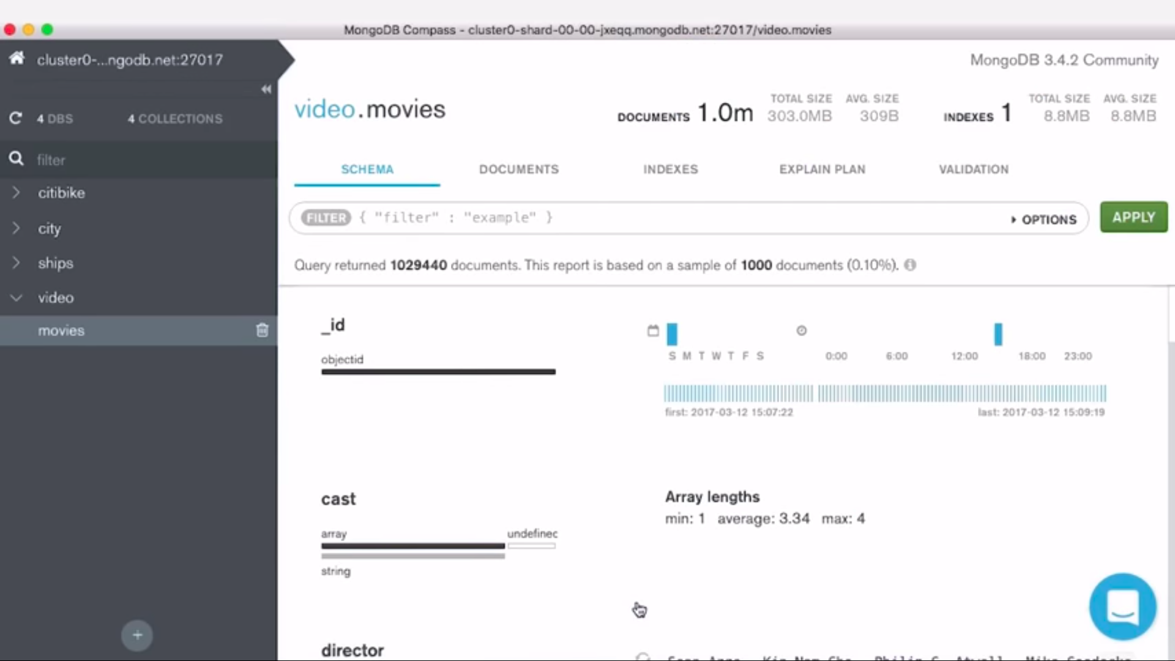

1. The schema view tells us about the list of fields found in document within this collection. Ex-cast, directors etc.
2. We have list of fields, their datatypes and summary of range of values for each fields found throughout the documents of this collection.

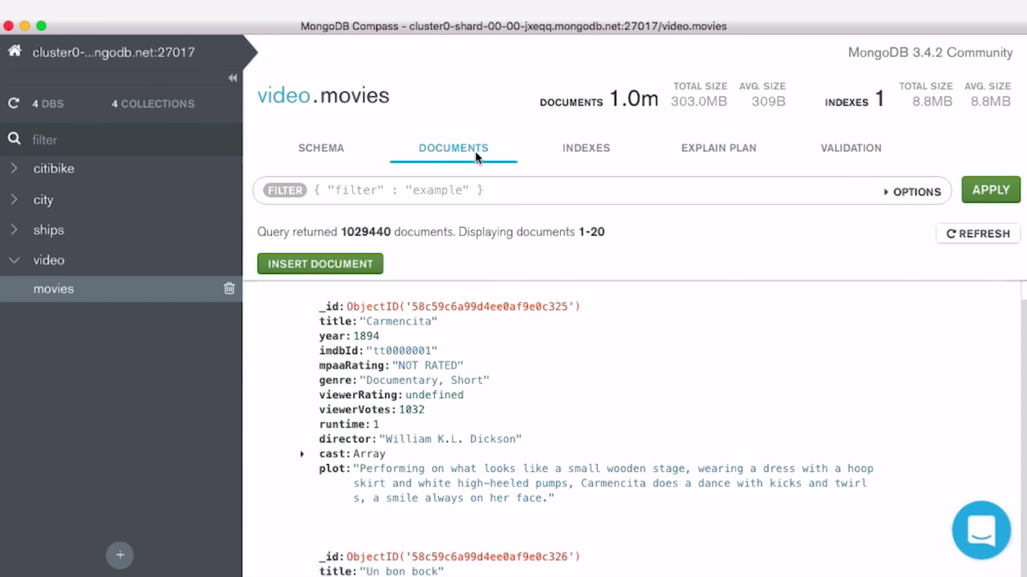

1. Documents provide the view of actual data found on this collection.
2. Since MongoDB has a flexible data Model, it’s not necessary that each documents should have the same data field.